Go to Jenkins
https://dlcdn.apache.org/tomcat/tomcat-9/v9.0.118/bin/apache-tomcat-9.0.118.zip

create a new job

give item name

select : pipeline

Fork : https://github.com/akshu20791/addressbook-cicd-project

pipeline{
agent any
stages{
stage("clone from github"){
steps{
git 'https://github.com/akshu20791/addressbook-cicd-project/'
echo 'clone done'
}
}
stage("compile the project"){
steps{
sh 'mvn compile'
}
}
stage("run the test cases"){
steps{
sh 'mvn test'
}
}
stage("package the project"){
steps{
sh 'mvn package'
}
}
}
}

Now we need to deploy the app

for that we need to use TOMCAT

which is webserver required to deploy the java based app

https://tomcat.apache.org/download-90.cgi

Right click on zip and copy address

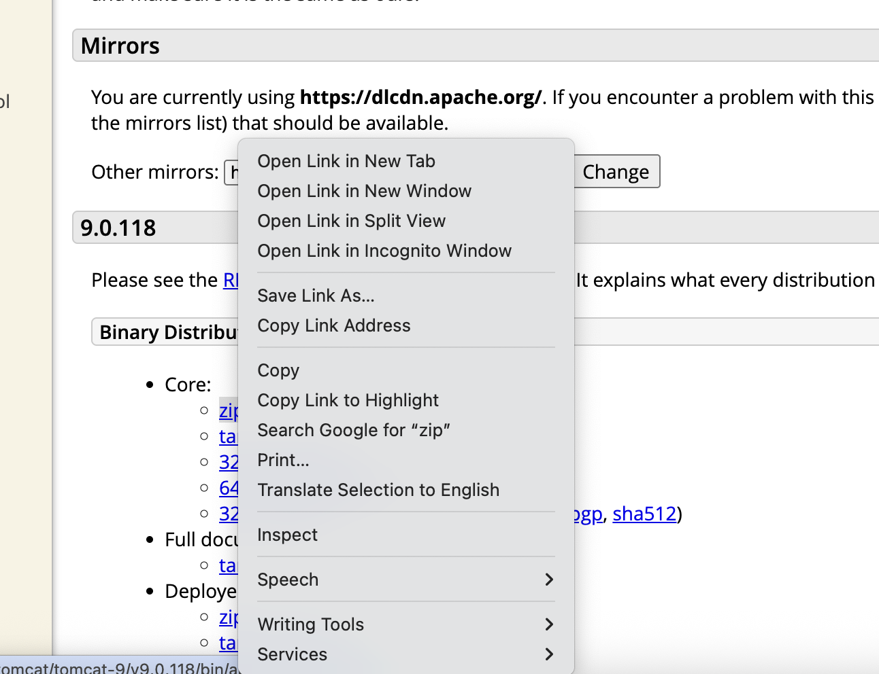
wget https://dlcdn.apache.org/tomcat/tomcat-9/v9.0.118/bin/apache-tomcat-9.0.118.zip

apt install unzip -y

unzip apache-tomcat-9.0.118.zip

So jenkins and tomcat works on port 8080...we cannot run two differnt software/app in same port

cd apache-tomcat-9.0.118

ls

cd conf

ls

Here you will see server.xml file

vi server.xml

Replace 8080 with 9090

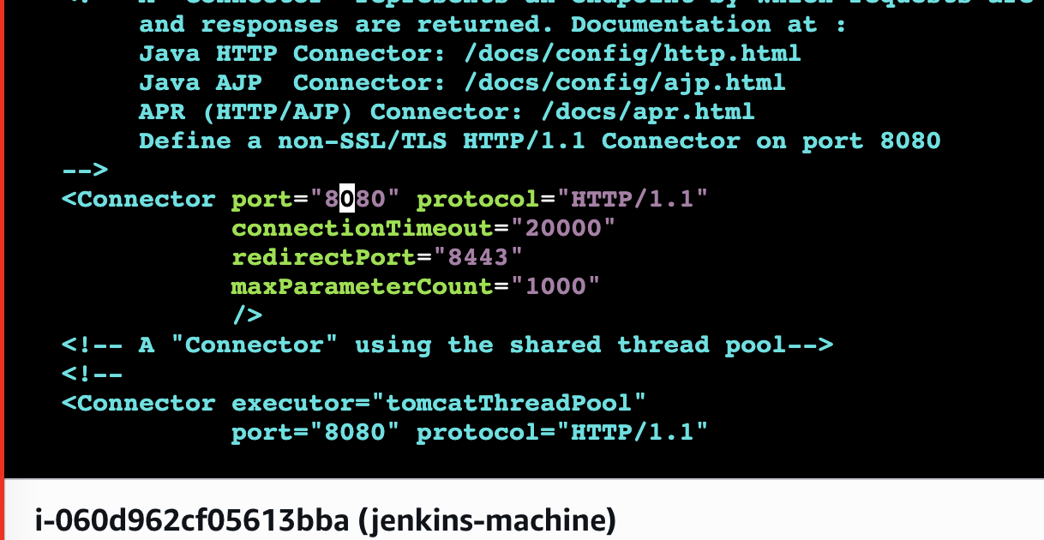
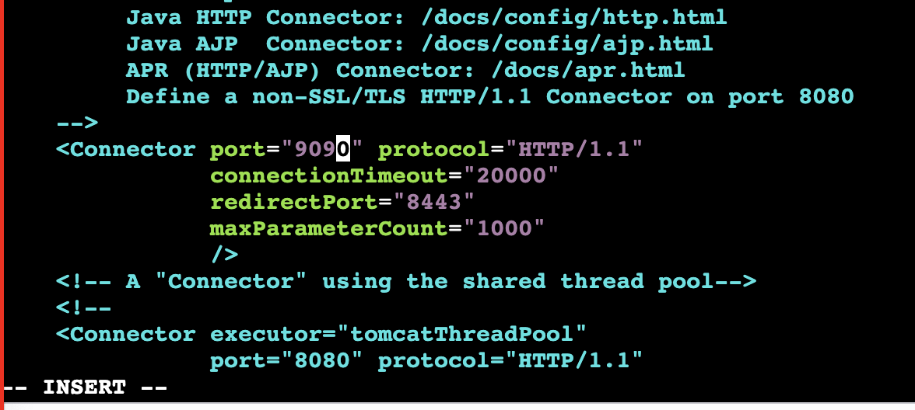
cd ..

cd bin

# you need to give read write and execiute permission to all the files ending with .sh

chmod +x *.sh

./startup.sh

your tomcat will not run on port 9090

publicip:9090

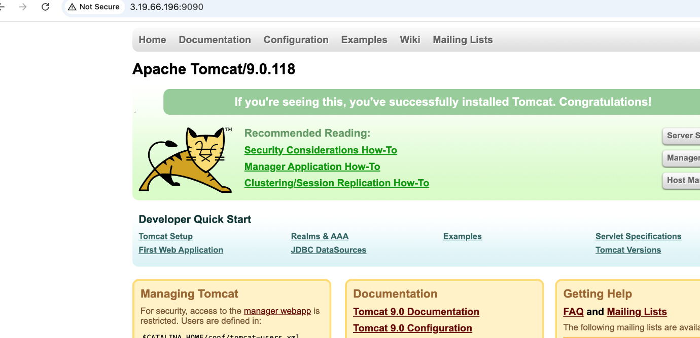
cd ..

To deploy java app ...what ever package (jar or war) is created we need to copy it to webapps directory inside the tomcat folder

Lets first check where the package is created

lets go to jenkins...lets build the job
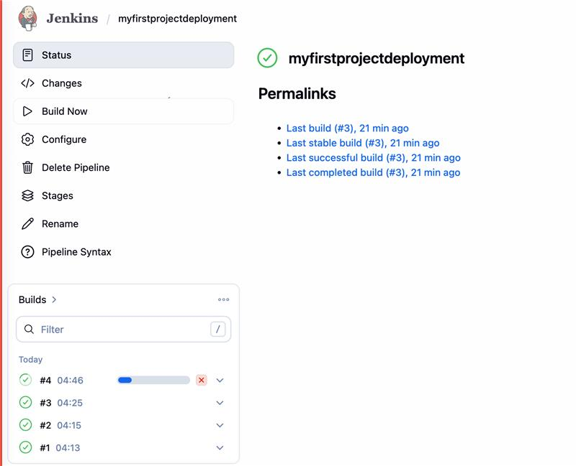
click on your latest build..if success

clcik on console output
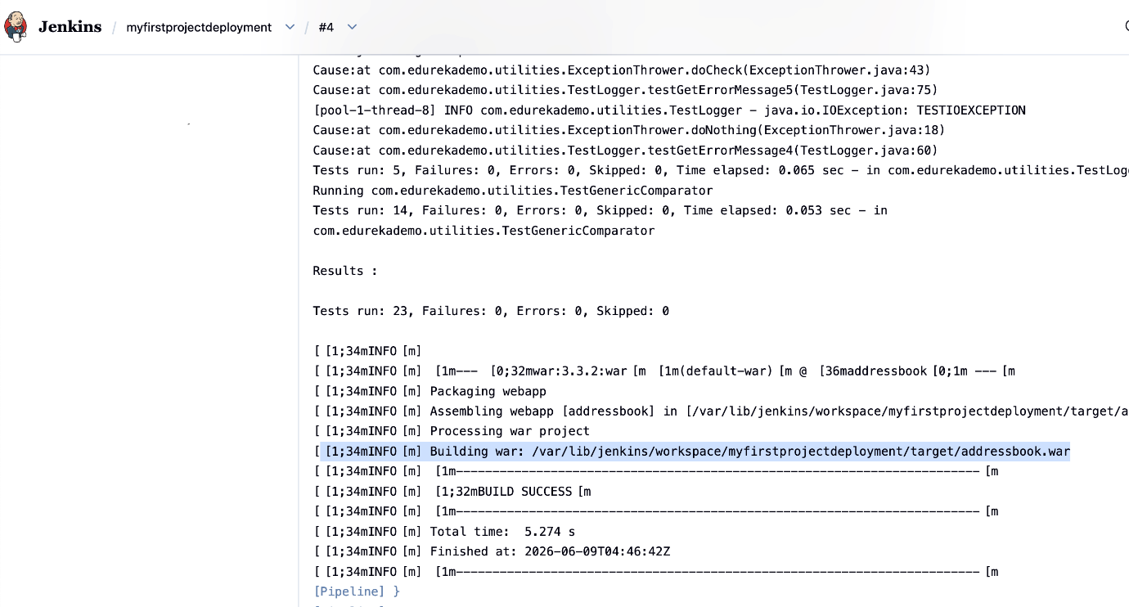
in logs you will find this..this is basically the war file createed by jenkins

copy the location

put it in notepad

now go back to your machine and check the location of webapps directory

cd webapps

pwd
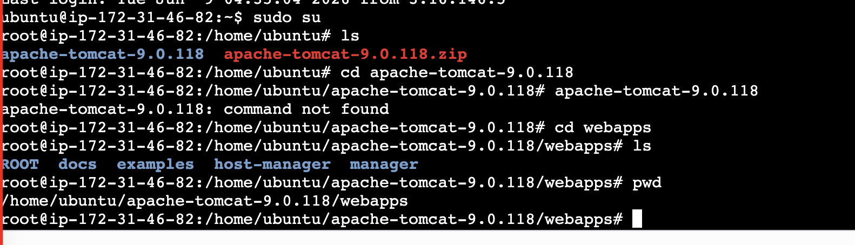
copy the location
/home/ubuntu/apache-tomcat-9.0.118/webapps

Go to jenkins --- go to your pipeline -- configure
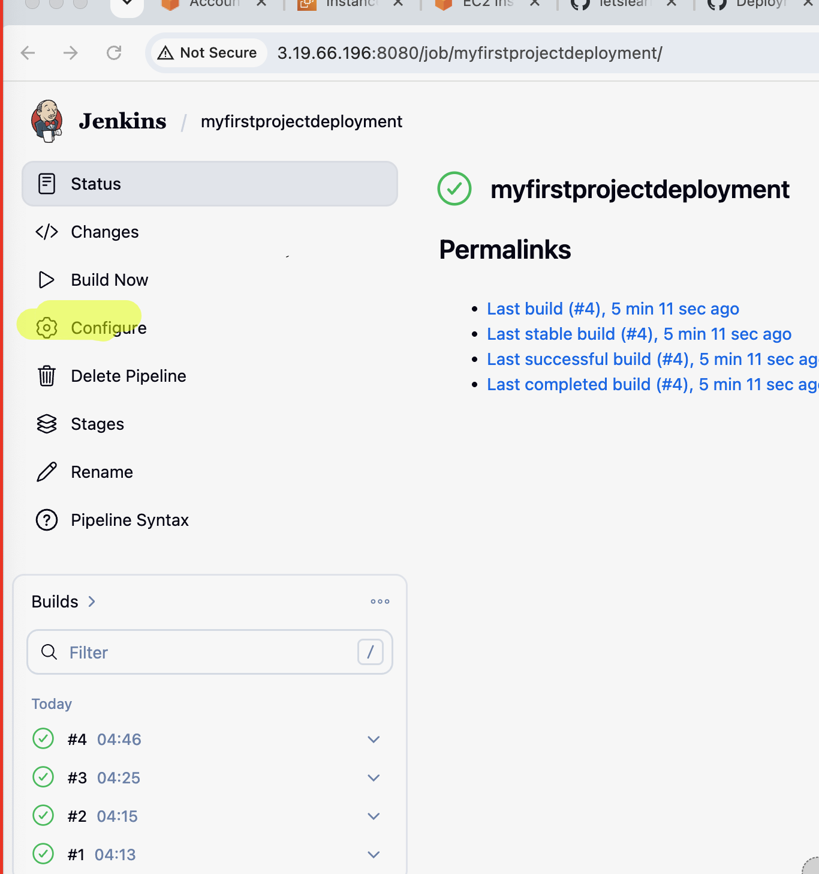
lets now complete the pipeline

We will add up the deploying stage where in the steps we will mention:
sudo cp sourcelocation of war file destination

pipeline{
agent any
stages{
stage("clone from github"){
steps{
git 'https://github.com/akshu20791/addressbook-cicd-project/'
echo 'clone done'
}
}
stage("compile the project"){
steps{
sh 'mvn compile'
}
}
stage("run the test cases"){
steps{
sh 'mvn test'
}
}
stage("package the project"){
steps{
sh 'mvn package'
}
}
stage("deploying the project to tomcat"){
steps{
sh "sudo cp /var/lib/jenkins/workspace/myfirstprojectdeployment/target/addressbook.war /home/ubuntu/apache-tomcat-9.0.118/webapps"
}
}
}
}

You have to change the location of your source and destination

Build now

you will get the error !!!

This error says that your jenkins user does not have sudo permission so copy will not work...we need to give admin permission to jenkins
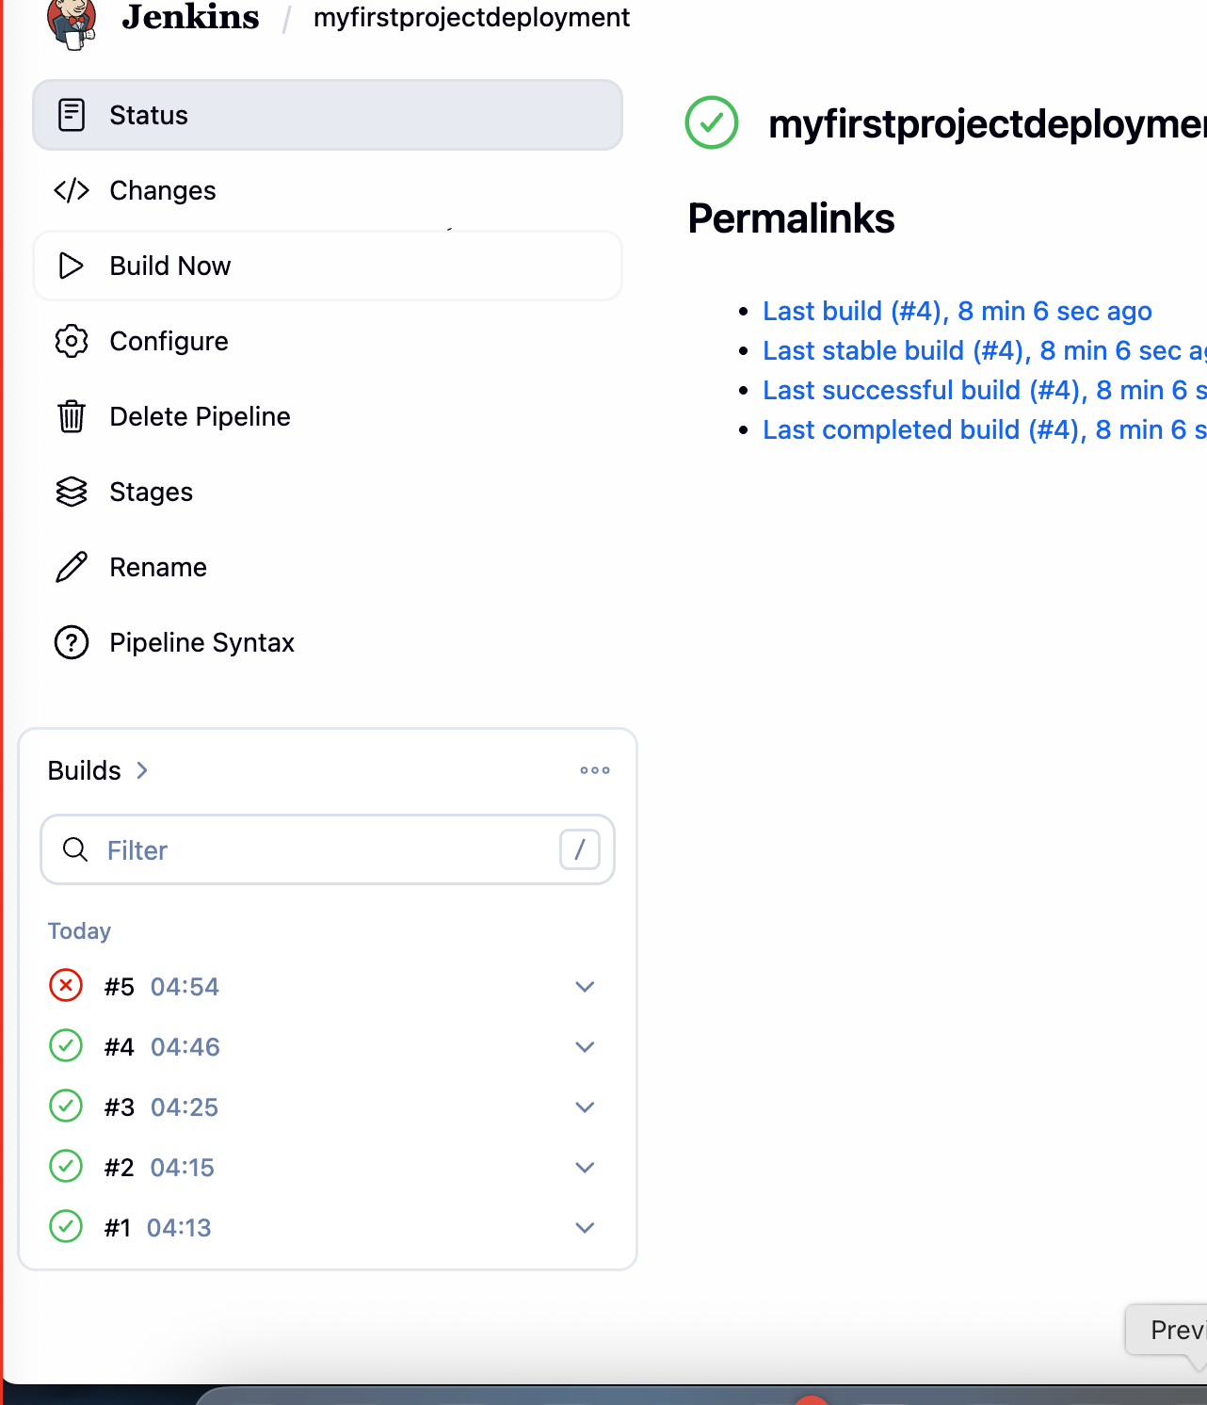

Click on error build

go to console outpout
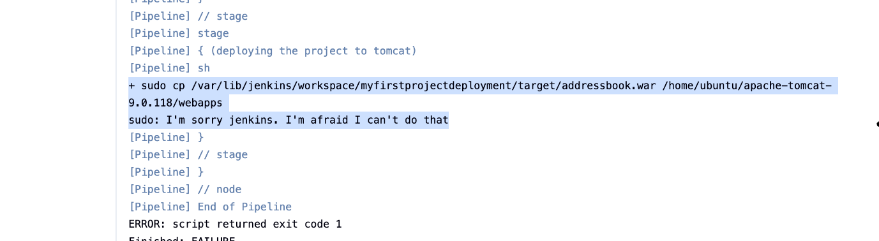

because jenkins does not have root permission

We will now give the root permission to jenkins ...

Go to machine ...there is a sudoers file...

visudo

jenkins ALL=(ALL:ALL) NOPASSWD: ALL

(put this below root)
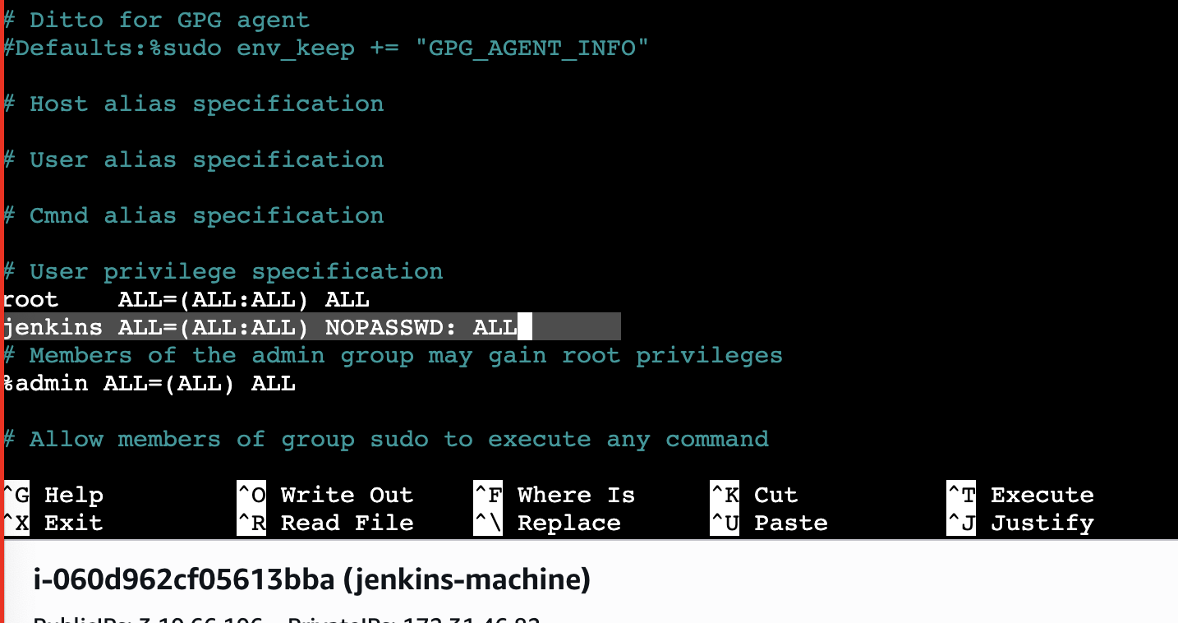

ctrl x ->y -> enter to come out of the file
For this permission to take place we need to restart jenkins

service jenkins restart
you need to relogin the jenkins from browser

build the job again

Go to your job -> build now
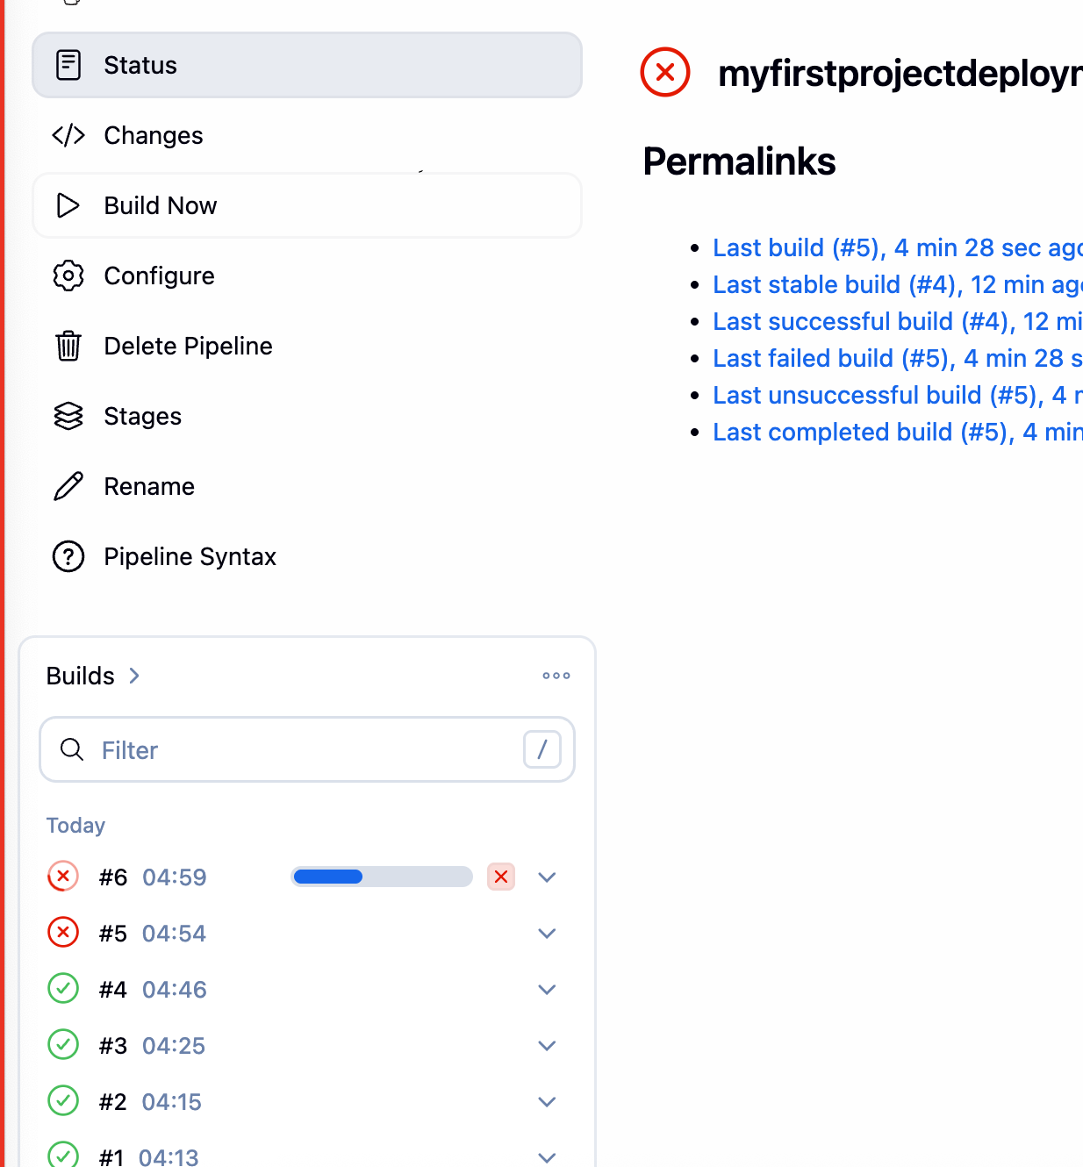

Wait for it to be success

if you get error you can put the logs in chatgpt and try to identify issuer

build is success
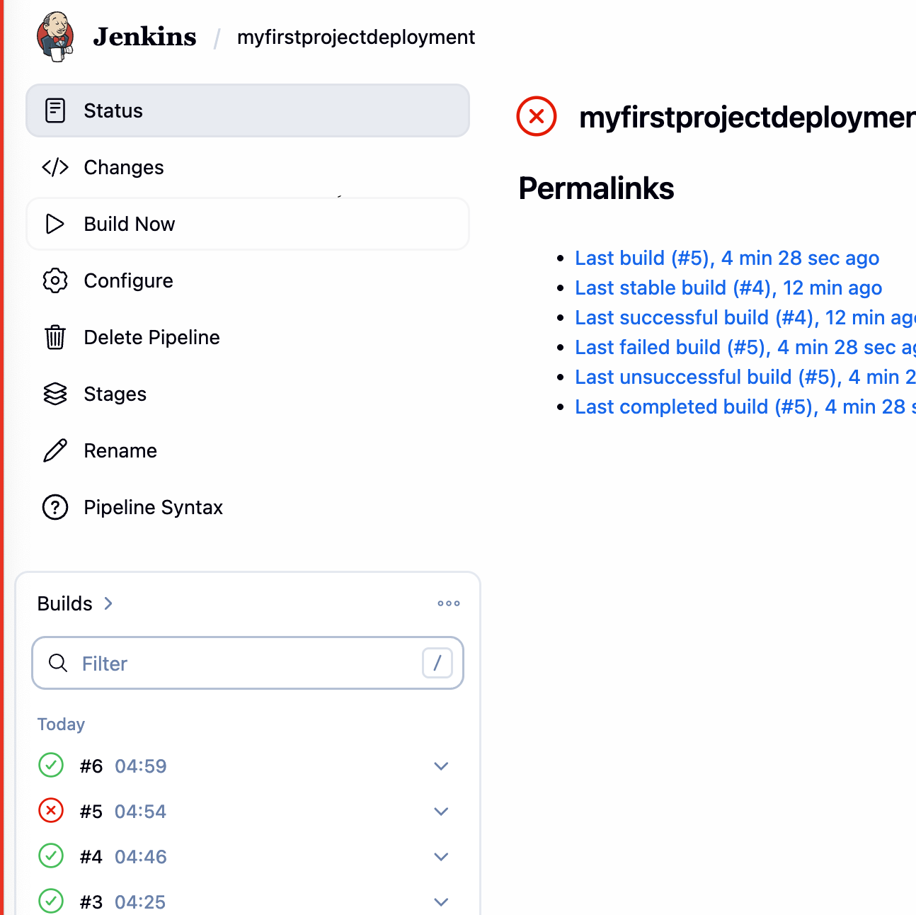

let see if app is running:
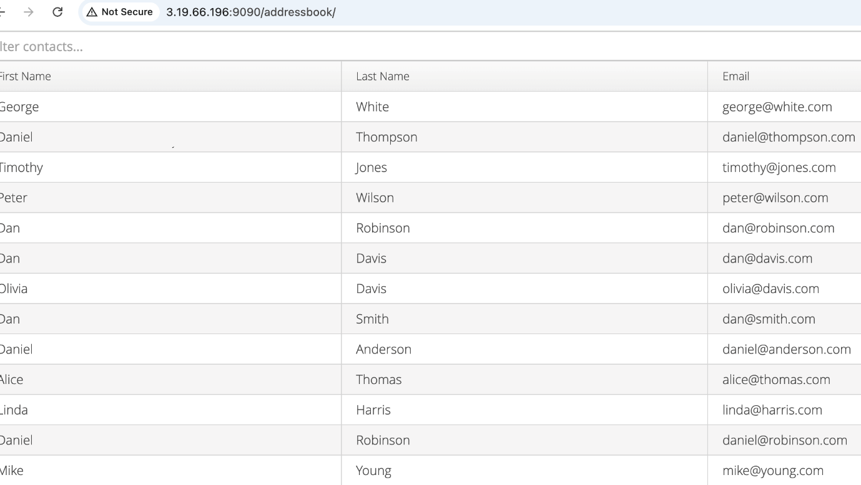

http://publicipofmachine:9090/addressbook

in my case: http://3.19.66.196:9090/addressbook/

